History Of the Periodic Table
Dmitri Mendeleev
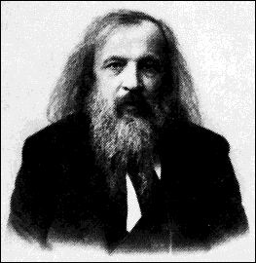 | Dmitri Mendeleev, a Russian scientist born in Siberia in 1834, is known as the father of the periodic table of the elements. The periodic table of the elements is an important tool used by students and chemists around the world to help them understand and simplify the often complex world of chemical reactions.
Mendeleev was Professor of Chemistry at the University of St. Petersburg (now Leningrad) in Russia. Mendeleev's work as a whole amounted to more than 400 books and articles as well as a large number of manuscripts which are preserved at the University of Leningrad. Mendeleev dedicated his life to research and education. Mendeleev made it his special responsibility to educate people wherever he went. When he traveled, Mendeleev would ride in the third class section of the train just to share findings with peasants over a cup of tea.
In 1869 Mendeleev arranged all the known elements (63 at that time) in order of increasing mass of the atoms. He found that the properties of elements repeated themselves at regular intervals. He arranged them in the form of a table so that athe elements with similar properties would fall into a vertical comumn. Because the properties of elements repeated themselves at regular intervals or periods the table is called the Periodic table of elements.
Mendeleev left gaps in the table to make the elements fit into proper columns and announced that the gaps represented elements not yet discovered. Mendeleev predicted the properties of the undiscovered elements by judging the properties of the elements above and below the gap in the table.
Mendeleev died on January 20, 1907 at the age of 73. A copy of the Periodic table was carried high over his funeral procession as a fitting emblem of Mendeleev's career.
For more information on History of Periodic Table or on the discovery and naming of each element simply click on the hyperlink!

The Periodic Table  The Periodic table of the elements was devised by Dimitri Mendeleev in 1869. Mendeleev arranged the known elements in order of increasing atomic number and noticed that the properties of the elements repeat themselves at regular intervals. If you are not familliar with the Periodic Table take some time to examine the elements in the table below.If you click on an element the name and number will appear in the boxes below.  Try to memorise the names and symbols of the first twenty elements. | 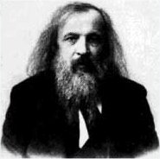
Teacher Area
Student Area

Periodic Table of the Elements
Top of Form
H |  |  |  |  |  |  |  |  |  |  |  |  |  |  |  |  | He
Li | Be |  |  |  |  |  |  |  |  |  |  | B | C | N | O | F | Ne
Na | Mg |  |  |  |  |  |  |  |  |  |  | Al | Si | P | S | Cl | Ar
K | Ca | Sc | Ti | V | Cr | Mn | Fe | Co | Ni | Cu | Zn | Ga | Ge | As | Se | Br | Kr
Rb | Sr | Y | Zr | Nb | Mo | Tc | Ru | Rh | Pd | Ag | Cd | In | Sn | Sb | Te | I | Xe
Cs | Ba | La | Hf | Ta | W | Re | Os | Ir | Pt | Au | Hg | Tl | Pb | Bi | Po | At | Rn
Fr | Ra | Ac
Bottom of Form
Top of Form
Name | Number | Mass
 |  | 
Bottom of Form
Legend
Metals | A solid substance that is a good conductor of eat and electicity. Can be formed into many shapes.
Metalloid | "Middle elements" - conduct heat and electricity better than nonmetals, but not as well as metals. Easier to shape than nonmetals, but not as easy as metals. Solid at room temperature.
Nonmetals | A poor conductor of heat and electricity. Not easily formed into shapes.

Note The Lanthanum and Actinium series have been omitted

Information about Elements.
Elements are represented in the Periodic Table by their chemical symbols. The chemical symbol may be one letter as in Carbon, or two letters as in Na (Sodium). If their are two letters in the symbol the second is always written in lowercase.
Besides the chemical symbol the Periodic Table usually gives the Atomic Number (above the symbol) and the Mass Number (below the symbol). Often the Mass Number is replaced by the Relative Atomic Mass
Structure of the Periodic Table
The Periodic Table is structured so that elements underneath each other have similar chemical properties The vertical columns which make up the Periodic Table are called Groups. Elements in the same group have similar chemical properties. Some groups have special names for example the elements from Group I are called the Alkali Metals
The Horizontal rows of elements are called Periods. The Atomic Number increases by one as you move across a period

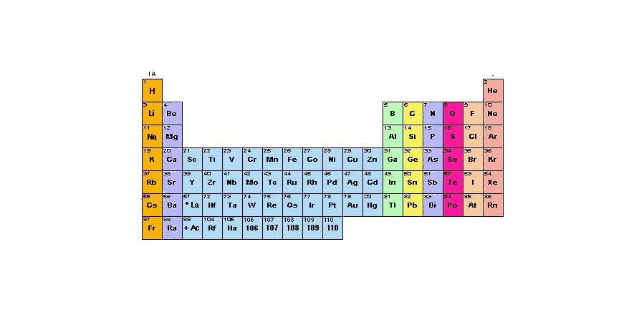

Copyright 2003 - Tony Burke- All Rights Reserved

